WICKHAM MARKET PARISH COUNCIL
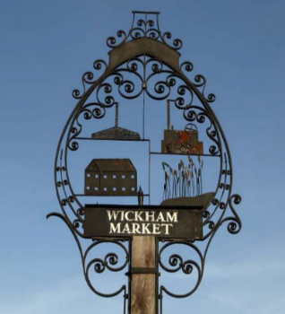
Chairman: Cllr Ivor French
Parish Clerk: Jo Peters, Neutral Farm House, Mill Lane, Butley, Suffolk. IP12 3PA
Tel: 01394 459400, E-Mail: wickhammarketparishclerk@gmail.com
www.onesuffolkwickhammarket.net

NOTICE IS HEREBY GIVEN THAT A VIRTUAL PLANNING COMMITTEE MEETING will be held on Thursday 8th April 2021 at 7:00pm via Zoom

AGENDA

MEMBERS OF THE PUBLIC AND PRESS ARE WELCOME TO ATTEND
(Please contact the Parish Clerk by 6:00pm on the day of the meeting for login details)
This meeting will be recorded by the Parish Clerk

- To receive apologies for absence

- To receive Councillors Declarations of Interest

- Open Public Session:–
Residents are invited to give their views and question the Parish Council on issues on this agenda or raise issues for future consideration at the discretion of the Chairman. Members of the public, whilst welcome to attend, may not take part in the meeting itself.

- To approve the minutes of the Planning Committee meeting held on Monday 1st February 2021

- To consider the following Planning Applications:-
Planning Ref: DC/21/1158/ADN
Proposal: Non-Illuminated Advertisement Consent - Shop sign applied lettering and logo.
Address: 75A High Street, Wickham Market (The Flaming Fryer)

Planning Ref: DC/20/4517/FUL
Proposal: To construct entrance porch/hallway to side of property single storey.
Address: 210 High Street, Wickham Market

Planning Ref: DC/21/1077/FUL
Proposal: Single storey flat roof extension to rear of property.
Address: The Croft, High Street, Wickham Market

- To consider any other applications received at the discretion of the Chairman

- Town and Country Planning Act 1990 - Appeal Under Section 78
Site at: Land Adjacent, 6 Spring Lane, Wickham Market, Suffolk
Planning Reference: DC/20/1895/FUL

- To consider correspondence received from Theberton & Eastbridge Parish Council regarding concerns with the openness and transparency of East Suffolk Council's planning protocol.

- Any other matters of report and items for the next meeting

Signed: Joanne Peters, Clerk to the Council Dated: 30th March 2021

