WICKHAM MARKET PARISH COUNCIL
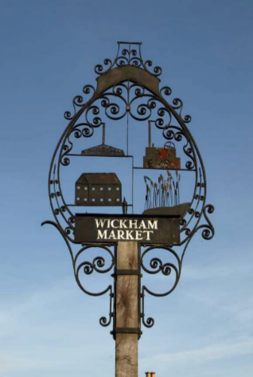
Chairman: Cllr Ivor French
Parish Clerk: Jo Peters, Neutral Farm House, Mill Lane, Butley, Suffolk. IP12 3PA
Tel: 01394 459400, E-Mail: wickhammarketparishclerk@gmail.com
www.onesuffolkwickhammarket.net

NOTICE IS HEREBY GIVEN THAT A PLANNING COMMITTEE MEETING will be held on Tuesday 22nd June 2021 at 7:00pm in Wickham Market Village Hall (Back Room)

AGENDA

Members of the public are welcome to attend. (Due to the current Coronavirus guidelines Wickham Market Village Hall (Back Room) can only hold 12 individuals, once this number has been reached no more attendees will be permitted to enter the hall)

- Election of Chairman

- To receive apologies for absence

- To receive Councillors Declarations of Interest

- Open Public Session:–
Residents are invited to give their views and question the Parish Council on issues on this agenda or raise issues for future consideration at the discretion of the Chairman. Members of the public, whilst welcome to attend, may not take part in the meeting itself.

- To approve the minutes of the Planning Committee meeting held on Thursday 8th April 2021

- To consider the following Planning Application:-
Planning Ref: DC/21/1158/AND
Proposal: Non Illuminated Advertisement Consent - Shop sign applied lettering and logo.
Address: 75A High Street, Wickham Market

- To consider any other applications received at the discretion of the Chairman

- Any other matters of report and items for the next meeting

Signed: Joanne Peters, Clerk to the Council Dated: 15th June 2021

