WICKHAM MARKET PARISH COUNCIL | 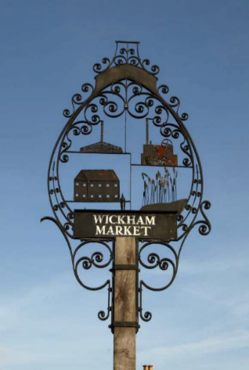
Chairman: Cllr Ivor French
Parish Clerk: Jo Peters, Neutral Farm House, Mill Lane, Butley, Suffolk. IP12 3PA
Tel: 07723 634169, E-Mail: wickhammarketparishclerk@gmail.com
www.onesuffolkwickhammarket.net

NOTICE IS HEREBY GIVEN A VIRTUAL MEETING OF THE ENVIRONMENT & LEISURE COMMITTEE will be held on Monday 19th April 2021 at 7:00pm via Zoom

Members of the public are welcome to attend. Please contact Joanne Peters,
Parish Clerk for the meeting login details

AGENDA
- Open Public Session

- To receive apologies for absence

- To receive declarations of interest

- To approve the draft minutes of the Committee meeting held on 15th February 2021

- Actions & Matters Arising from meeting held on Monday 15th February 2021:-
  - - Village Sign – Cllr Horsnell to report on next stages of work
  - - King Edward Ave – Footpath update
  - - Simons Cross Drainage update
  - - Church Pightle update

- Village Hall/Playing Field
  - - VHCIO, Bowls & Football club leases – To receive an update from Cllr Chenery
  - - Flooding and Potholes at the Village Hall Car Park – Way forward
  - – Village Hall Play Area Repairs – Way forward
  - – To consider matters relating to the Skate Park – Repairs required – To receive an
update from Cllr Horsnell
  - – Litter on the Playing Field

- Other matters
  - – Quiet Lanes update
  - – Hanging Baskets on the Hill – To consider options

- To consider any matters relating to the allotments
8.1 – To consider received from a local resident regarding Simons Cross Allotment site

- To consider any matters relating to the cemetery
9.1 – Rabbit Gassing programme of works
9.2 – Return of Cattle
9.3 – Cemetery Regulations

- Markets Update

- Village Handyman programme of works update

- Matters of report and items for the next meeting

- Date of the next meeting – Monday 21st June 2021

Signed: Joanne Peters, Clerk to the Council Dated: 12th April 2021

