WICKHAM MARKET PARISH COUNCIL | 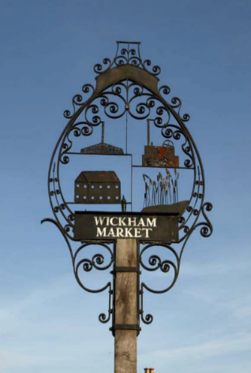
Chairman: Cllr Ivor French
Parish Clerk: Jo Peters, Neutral Farm House, Mill Lane, Butley, Suffolk. IP12 3PA
Tel: 07723 634169, E-Mail: wickhammarketparishclerk@gmail.com
www.onesuffolkwickhammarket.net

NOTICE IS HEREBY GIVEN THE NEXT MEETING OF THE ENVIRONMENT & LEISURE COMMITTEE will be held on Monday 21st June 2021 at 7:00pm in Wickham Market Village Hall (Back Room)

Members of the public are welcome to attend. (Due to the current Coronavirus guidelines Wickham Market Village Hall (Back Room) can only hold 12 individuals, once this number has been reached no more attendees will be permitted to enter the hall)

AGENDA

- Election of Chairman

- Open Public Session

- To receive apologies for absence

- To receive declarations of interest

- To approve the draft minutes of the Committee meeting held on 28th April 2021

- Actions & Matters Arising from meeting held on Monday 28th April 2021:-
  - - Village Sign – Cllr Horsnell to report on next stages of work and to agree costs
  - - VHCIO, Bowls & Football Club leases – To receive an update from Cllr Chenery
  - - Village Hall Play Area Repairs – Update

- Village Hall/Playing Field
  - – Village Hall Car Park – Way forward
  - – Village Hall Playing Field - Litter

- Other matters
  - – Quiet Lanes update
  - – Woman’s Cycle Tour – Saturday 9th October 2021
  - – ESC Welcome Back Fund update

- To consider any matters relating to the allotments

- To consider any matters relating to the cemetery
10.1 – Rabbit Gassing programme of works update
10.2 – Return of cattle and cutting of the paddock
10.3 – Approval of Cemetery Regulations

- Markets Update

- Matters of report and items for the next meeting

- Date of the next meeting – Monday 16th August 2021

Signed: Joanne Peters, Clerk to the Council Dated: 14th June 2021

