WICKHAM MARKET PARISH COUNCIL | 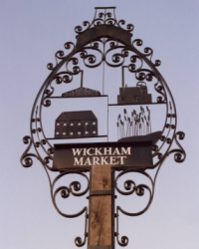
Chairman: Cllr Ivor French
Parish Clerk: Jo Peters, Neutral Farm House, Mill Lane, Butley, Suffolk. IP12 3PA
Tel: 07723 634169, E-Mail: wickhammarketparishclerk@gmail.com
Website: www.onesuffolkwickhammarket.net

NOTICE IS HEREBY GIVEN THAT AN EXTRAORDINARY MEETING
of the Staffing & Personnel Committee will be held on Monday 2nd August 2021
at 7:00pm in Wickham Market Village Hall, Committee Room

AGENDA

- To receive apologies for absence

- To receive Councillors Declarations of Interest

- Resolution to consider that, under Section 2 of the Public Bodies (admission to Meetings) Act 1960, the press and public be excluded from the meeting

- Parish Council Issues

- Any other matters of report

Signed: Joanne Peters, Clerk to the Council Dated: 29th July 2021

